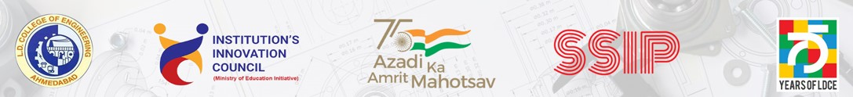
Report on
SSIP 2.0 - Sensitisation, Felicitation of SIH 2022 teams & Launching of Digital IdeathonSponsored by e-Infochips

Program details:

Topic: SSIP 2.0 - Sensitisation, Felicitation of SIH 2022 teams & Launching of Digital IdeathonSponsored by e-Infochips

Date: 23 September 2022

Time: 4.00 PM to 5.30 PM

Venue: Vishwakarma Hall (WRM), L. D. College of Engineering, Ahmedabad.

Chief Patron :Dr.RajulK. Gajjar
(Principal- L. D. College of Engineering, Ahmedabad.)

Patron :Dr. Ketan Badgujar
(InchargePrincipal- L. D. College of Engineering, Ahmedabad.)

Chief Guest: Shri H. S. Patel
(MP- Loksabha Ahmedabad East)

Guest of Honour: Shri Anand Shah and Shri Bhavik Vora
(Senior executives from e-Infochips)

Convener: Dr. Manish Thakker, Head IC dept andDr. C. H.Vithalani, Head EC Department

Student Participation: 85 Students across all the branches and semesters.

Banners for the Event:
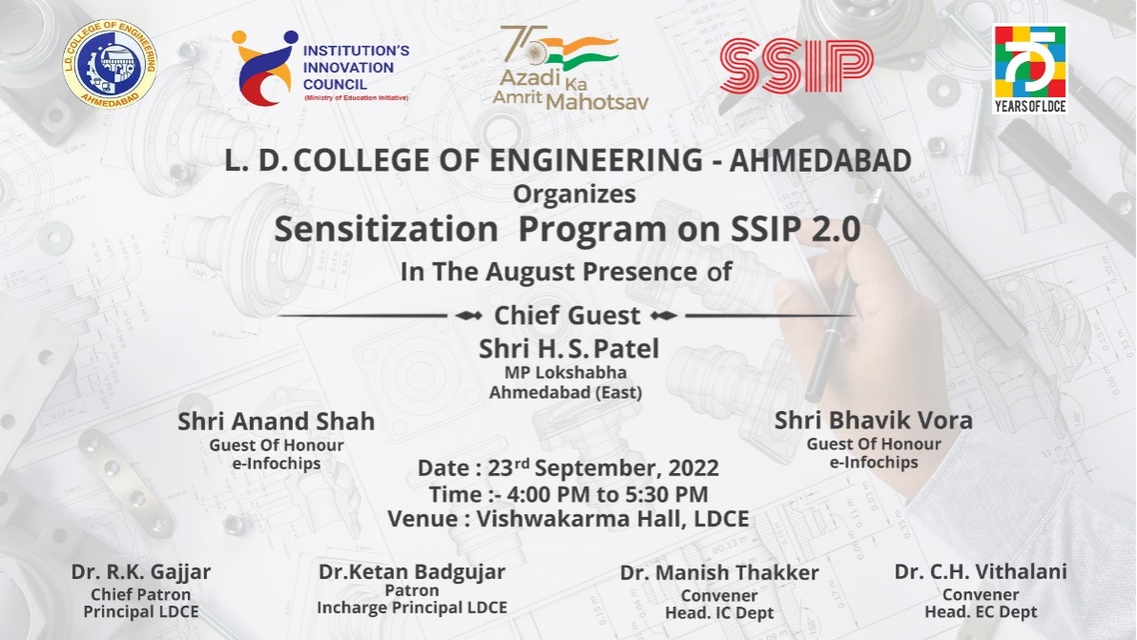
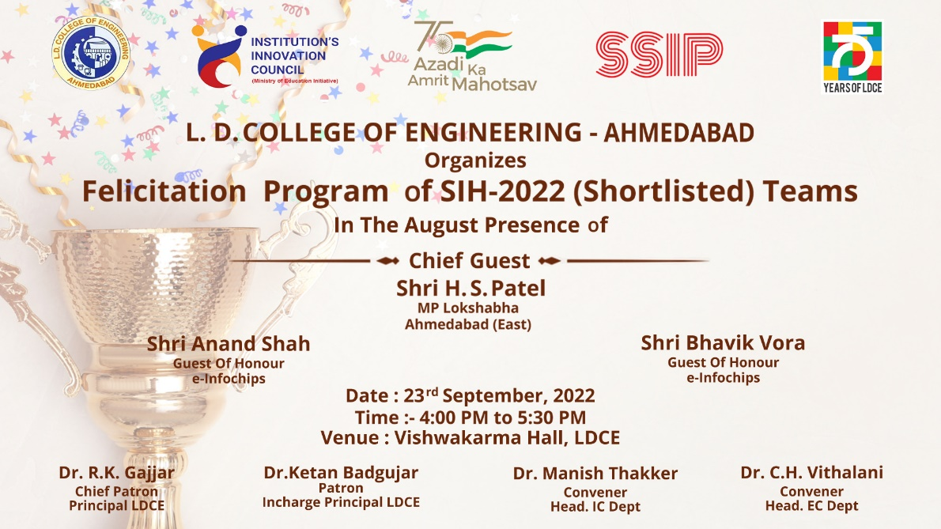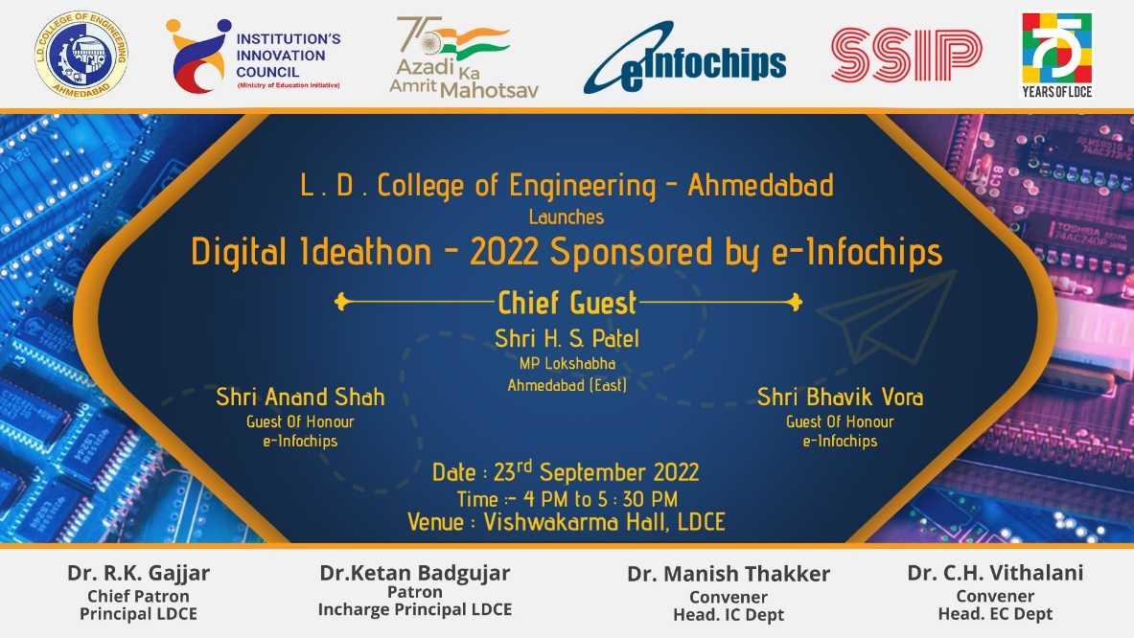
Brief about the Program:

This program was organised to flow the information about SSIP -2.0 Policy among the students so that the students can come up with their ideas for the new generation technology evolvement. The program started with the lighting ceremony of goddess Saraswati with the hand of chief guest, guest of honours and other dignitaries. The in charge principal of LDCE then gave light to the success story of LDCE in the field of innovations and achievements in SIH-2022. Shri gaveand a kick start launch to the digital ideathon sponsored by e-Infochips and enlighten the students about future technologies and possibilities of inventions. Shri. H. S. Patel – chief guest , then gave a wonderful speech on how government is focusing on the innovation policy and road map to develop young entrepreneur. After that the felicitation program was executed to appreciate the participates of SIH=2022. At last Dr C. H. Vithalani gave the vote of thanks to all the dignitaries and the program coordinators.
Photographs of the Event:
